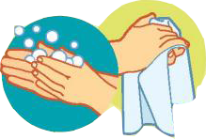

**Call before visiting**

**your doctor**

**Clean and disinfected**

**“high touch” surfaces**

**often**

**Cover your mouth with a**

**tissue or sleeve when**

**coughing or sneezing**

Clean all “Hight-touch” surfaces every day

**Avoid touching your eye, nose**

**or mouths with unwashed**

**hands or after touching**

**surface**

**When a cloth face cover when**

**going out in public**

**Wash hands often with soap**

**and water for 20 seconds or**

**longer and dry hand with a**

**clean towel or ai dry**

**Get adequate sleep and get well**

**balanced meal**

**Avoid contact with people who are**

**sick**

**Stay home when**

**you are sick**

Protect yourself from all infectious disease by using precautions

**The Hight touch surface includes counter, tabletops, doorknob, bathroom fixtures, toilets, phones, keyboards, tables.**

**Use a household cleaning spray or wipe, according to label instructions, label contains instructions for safe and**

**effective use of the cleaning product**.